T.Praneetha
192412588
ECA3102
NANO ELECTRONICS
Exp. 5. Band Structure Simulation for Graphene and CNTs using Nano Hub

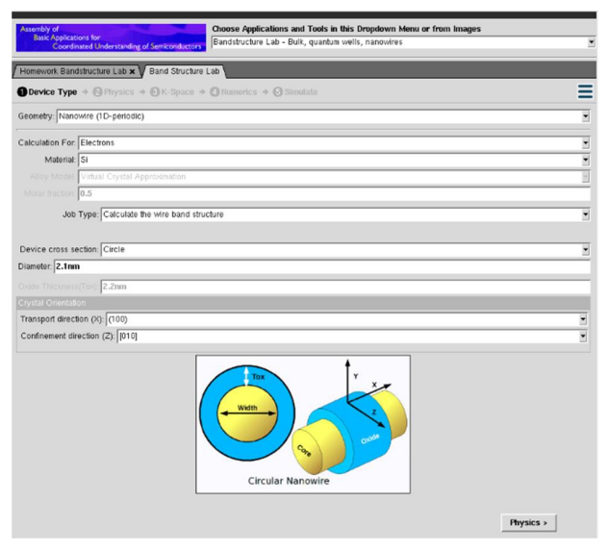

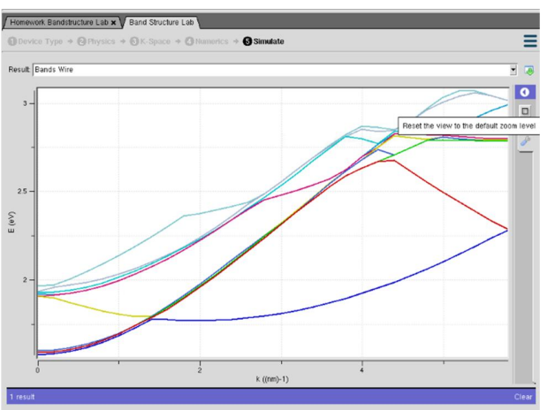

The objective was to study the band structure of Graphene and Carbon Nanotubes (CNTs) using the NanoHUB online simulation tool. The simulation was performed by selecting Graphene and CNT materials and analyzing their energy band structures while keeping the simulation parameters constant. The purpose of this experiment was to understand how the electronic band structure influences the electrical properties of these nanomaterials. Graphene exhibits a zero band gap with linear energy dispersion near the Dirac point, making it an excellent conductor, whereas Carbon Nanotubes may exhibit either metallic or semiconducting behavior depending on their chirality and diameter. By comparing the band structure graphs of Graphene and CNTs, the experiment demonstrates how material structure affects the electronic properties and highlights their importance in nanoelectronics and advanced semiconductor devices.

Case Study 1: Simulate the band-structure of InAs circular nanowire
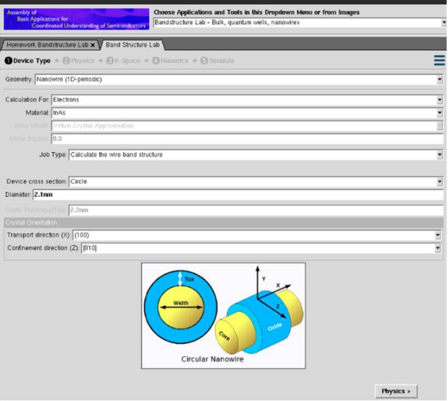
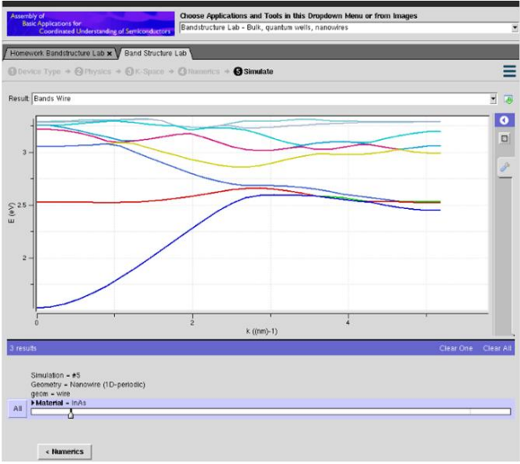
the objective was to simulate the band structure of an InAs circular nanowire using the NanoHUB online simulation tool. The simulation was carried out by selecting Indium Arsenide (InAs) as the nanowire material with a circular geometry, while keeping the other simulation parameters constant. The purpose of this study was to analyze the electronic band structure and understand the effect of quantum confinement in a circular nanowire. Due to the nanoscale dimensions, electrons are confined within the nanowire, resulting in quantized energy levels and modified band dispersion. By observing the band structure graph, the simulation demonstrates how the circular geometry influences the electronic properties of the InAs nanowire, making it suitable for high-speed nanoelectronic and optoelectronic applications.

Case Study 2: Simulate the band-structure of AlGaAs circular nanowire
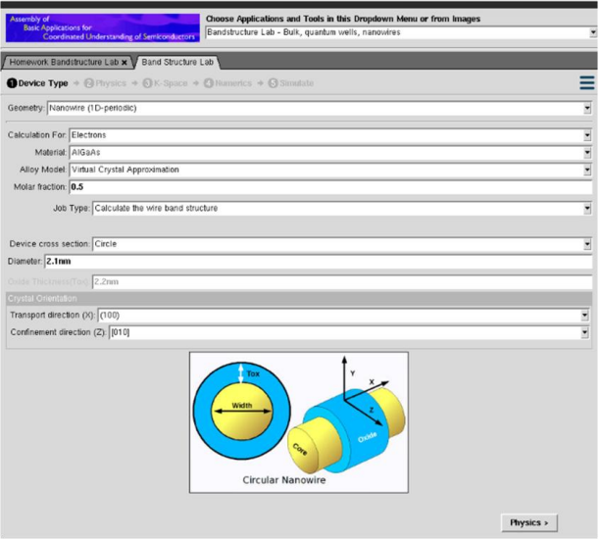
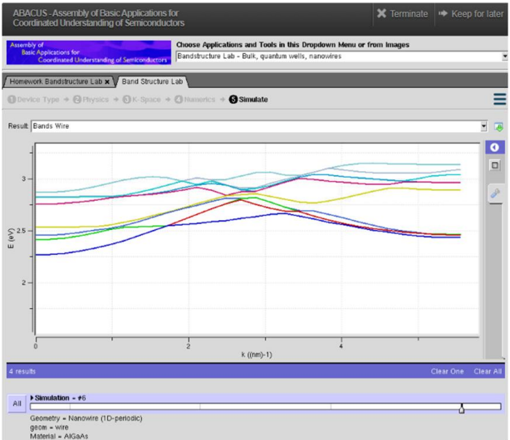
the objective was to simulate the band structure of an AlGaAs circular nanowire using the NanoHUB online simulation tool. The simulation was carried out by selecting AlGaAs (Aluminum Gallium Arsenide) as the nanowire material with a circular geometry, while keeping the other simulation parameters constant. The purpose of this study was to investigate the electronic band structure and understand the effect of quantum confinement on the nanowire. Due to the nanoscale dimensions, electrons are confined within the nanowire, resulting in discrete energy levels and modified band dispersion. By observing the band structure graph, the simulation demonstrates how the material properties of AlGaAs influence the electronic characteristics of the nanowire, making it suitable for optoelectronic and high-speed semiconductor devices.
Conclusion
The simulations successfully demonstrated the band structures of InAs and AlGaAs circular nanowires using NanoHUB. The results show that the material type and nanowire structure significantly influence the electronic band structure and energy levels due to quantum confinement. These findings confirm the importance of band structure analysis in designing high-performance nanoelectronic and optoelectronic devices.

